Machine Description | Nappings is a Linux boot-to-root VM where an attacker gains access through an exposed web application containing a command-injection flaw. The foothold provides a limited shell which is escalated to root by abusing insecure SUID binaries and misconfigured local privileges.
Target IP | 10.136.108.179
Vulnerability Name | Unauthenticated Command Injection in Web Application
Service / Version | TCP 80 / HTTP
CVSS Score / Severity | 9.8 Critical
Attack Vector | AV:N/AC:L/PR:N/UI:N/S:U/C:H/I:H/A:H
Proof Of Concept | STEP 1 – Discover Target IP using Netdiscover  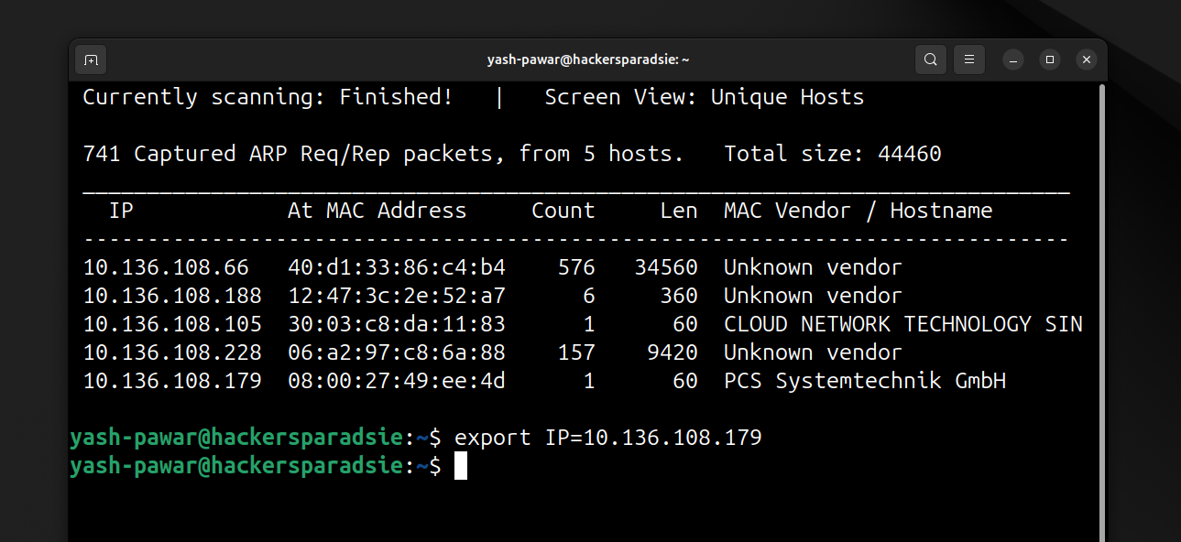  STEP 2 – Scan the target for open ports and services  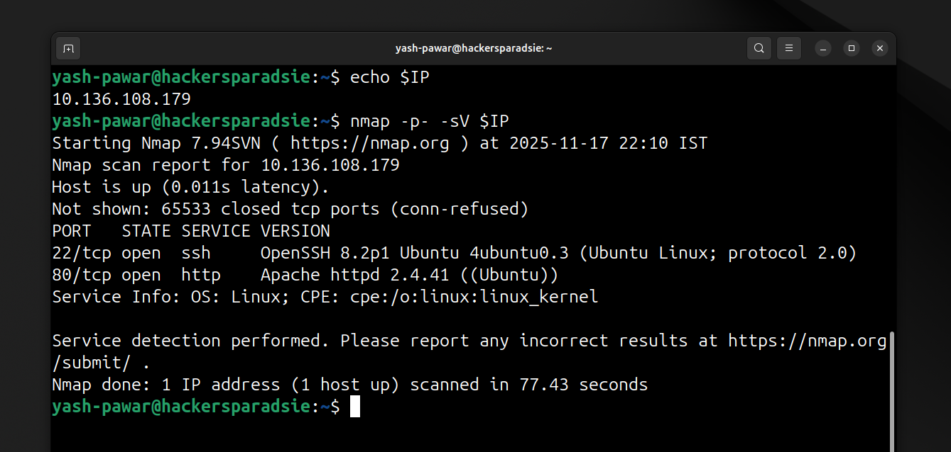  STEP 3 – Enumerate HTTP 80  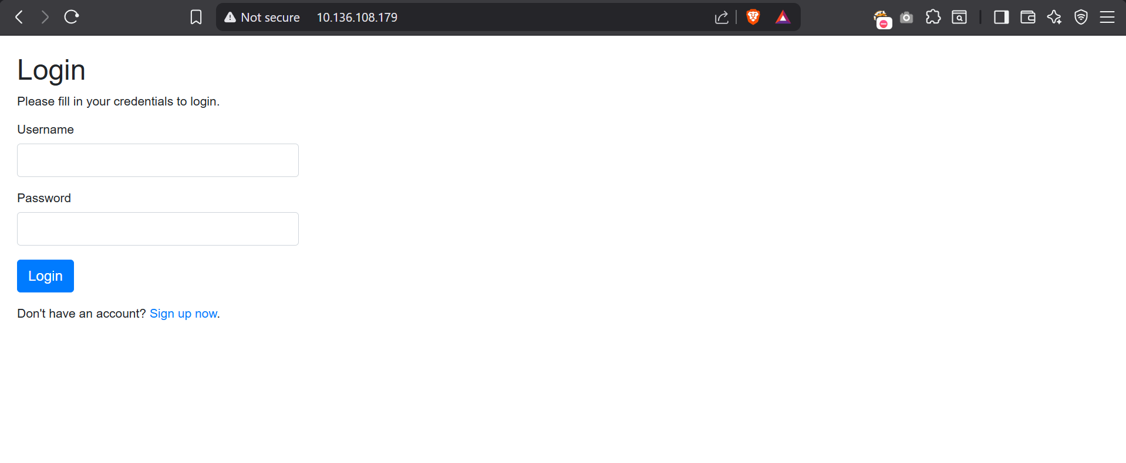  - It has option to create new user lets create one  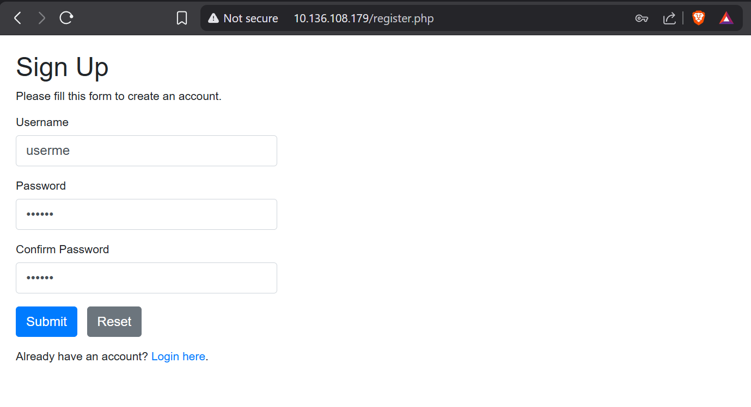  - Login with created user  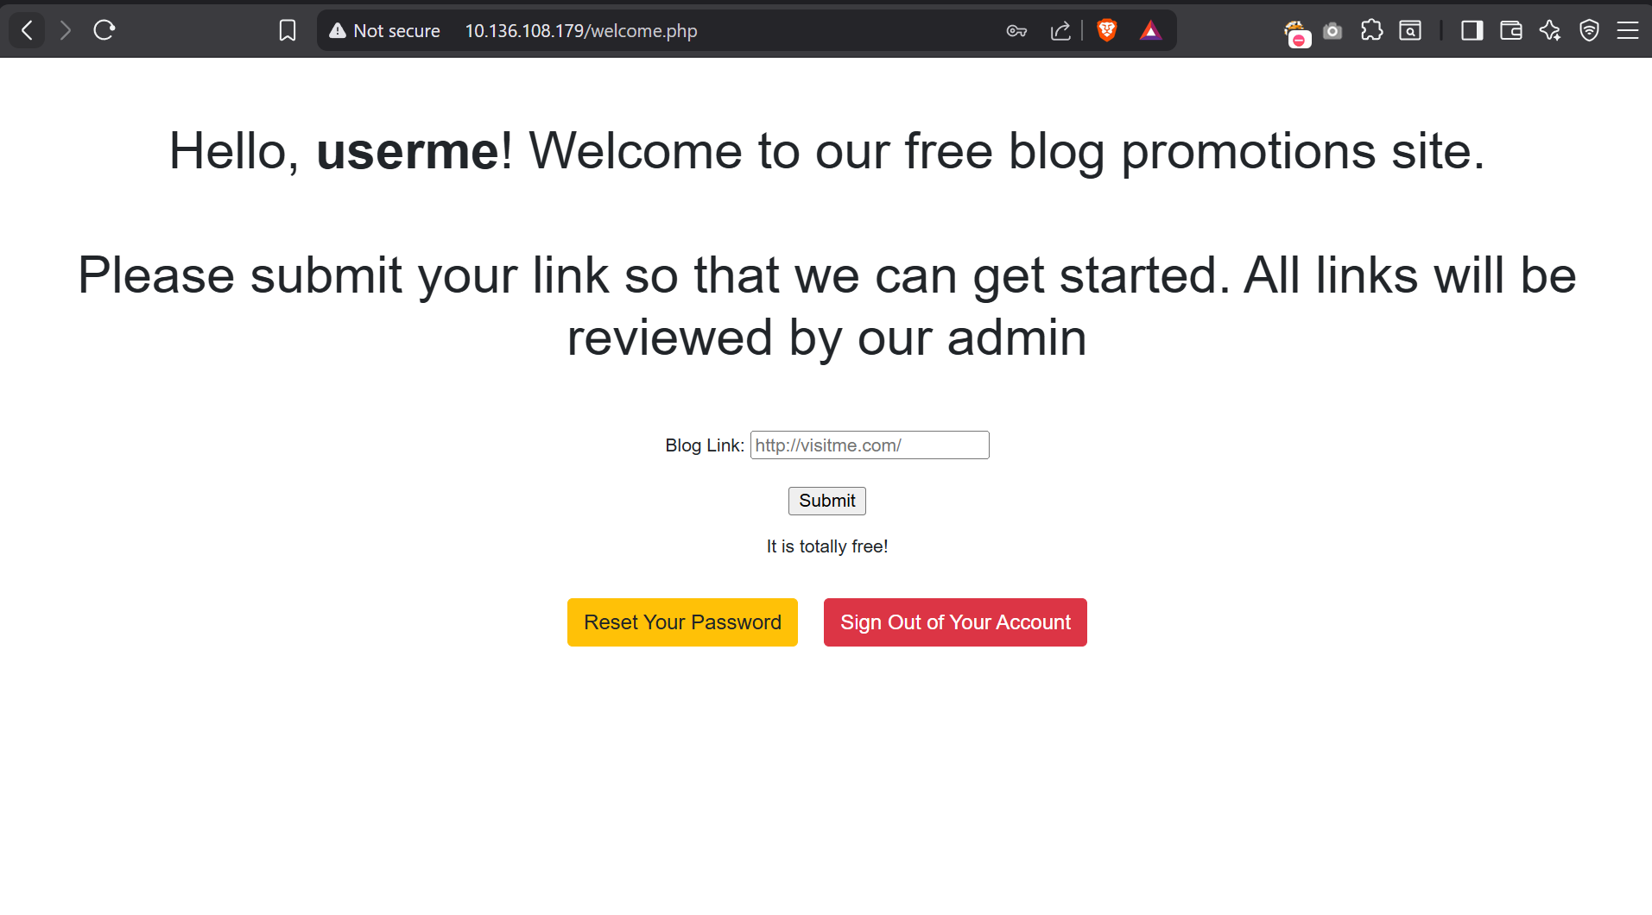  STEP 4 – Fuzzing for Directories and files on server  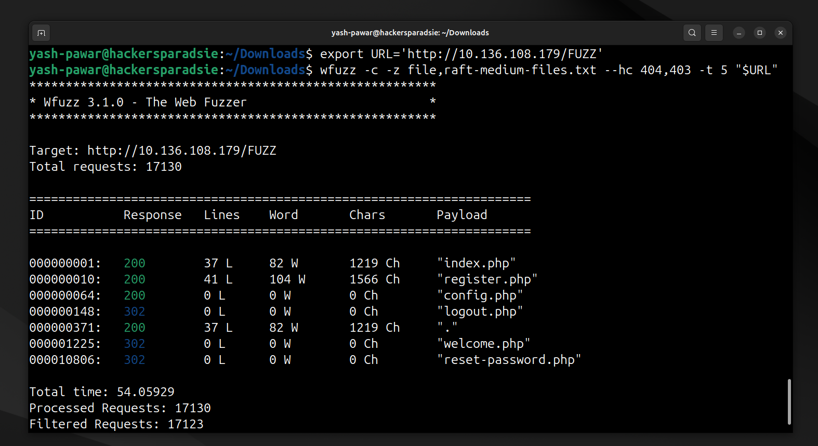  - No directories on server  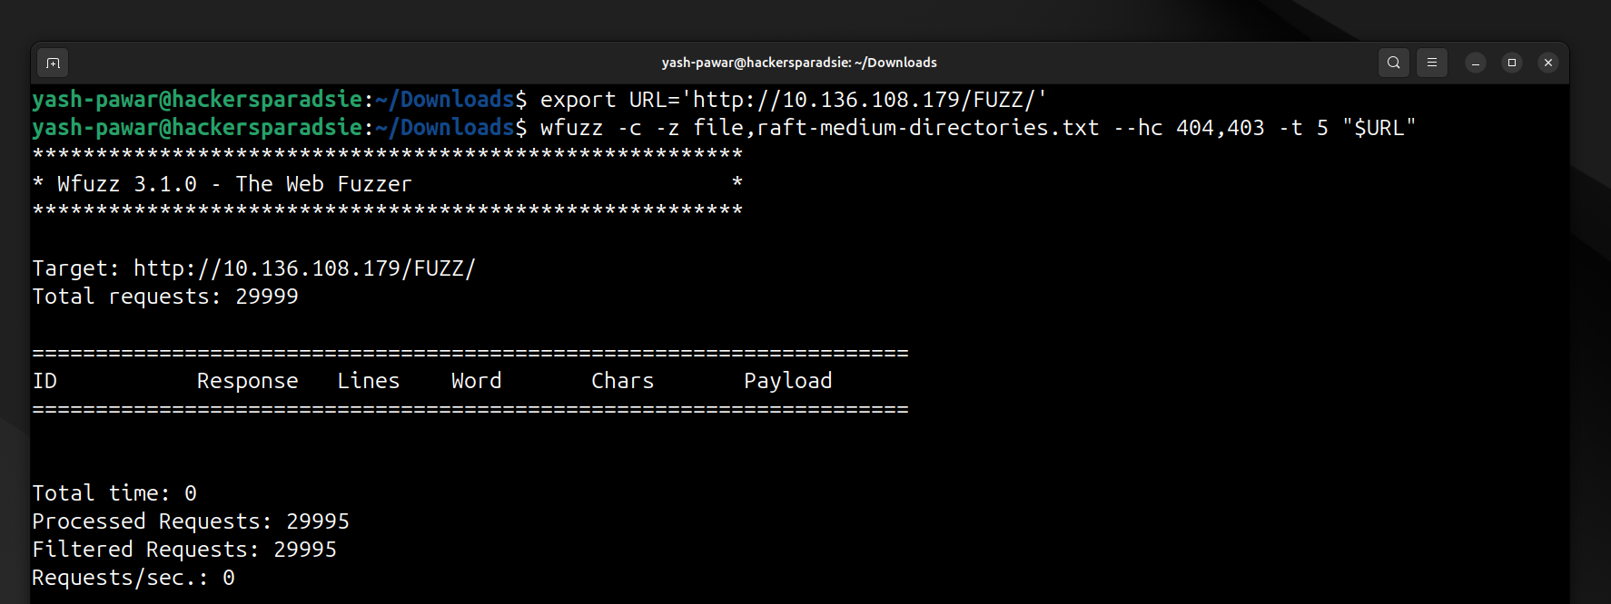  STEP 5 – Lets enumerate /welcome.php endpoint  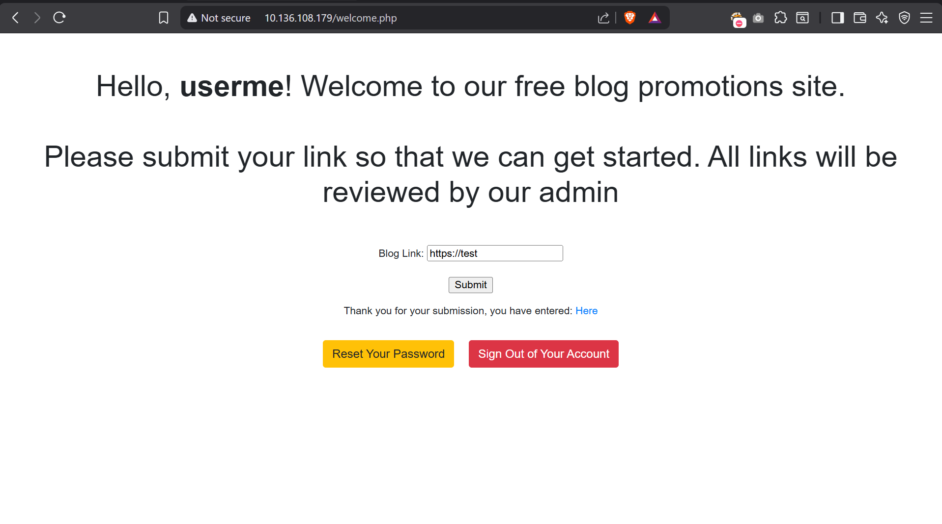  - Insert link and submit and let’s look for source code  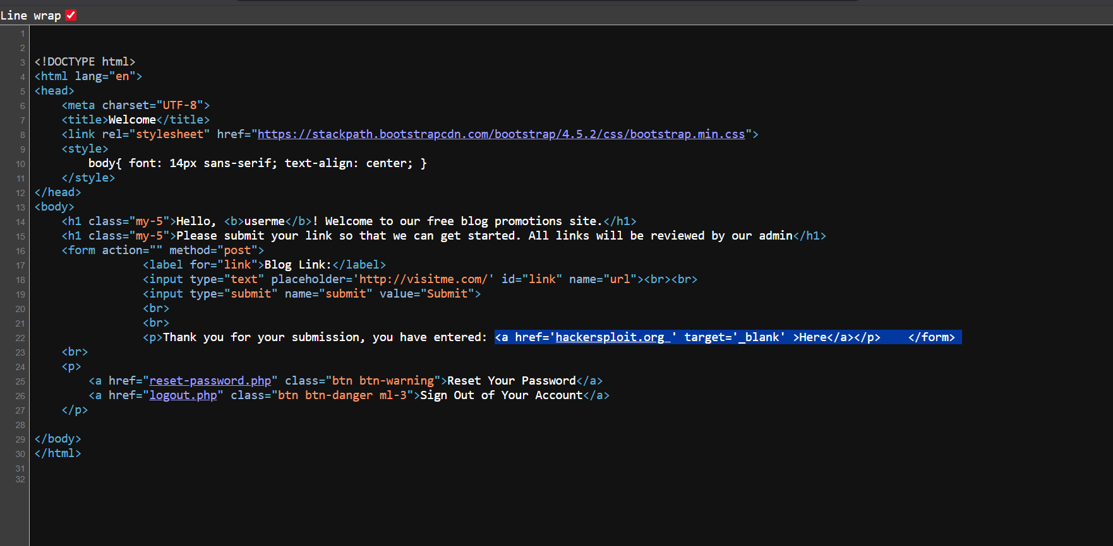  - Nothing really interesting at a first look, but if we look closely, we notice a very known vulnerability in the link syntax(target=’_blank’) called “tabnabbing”. Click here if you want to learn more.  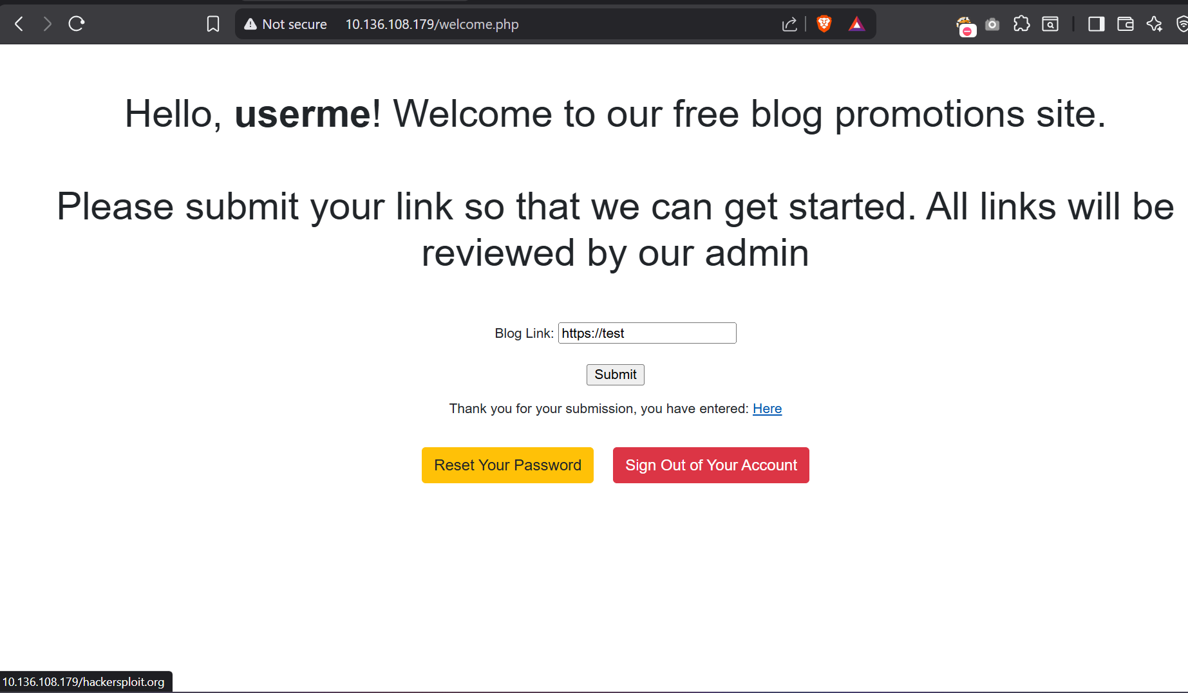  STEP 6 – Create vfile.html  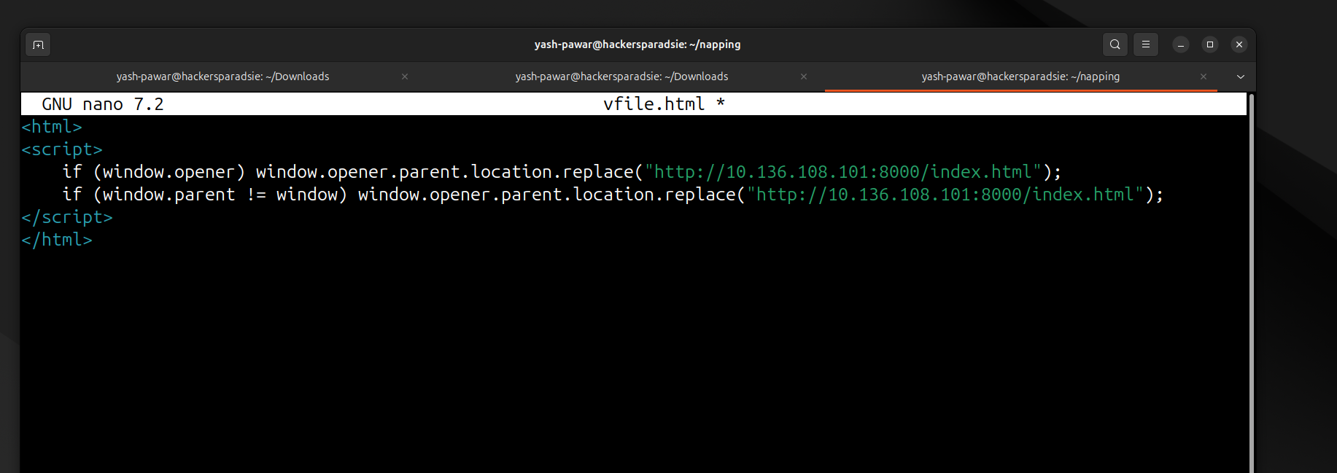  - Copy code of index.php  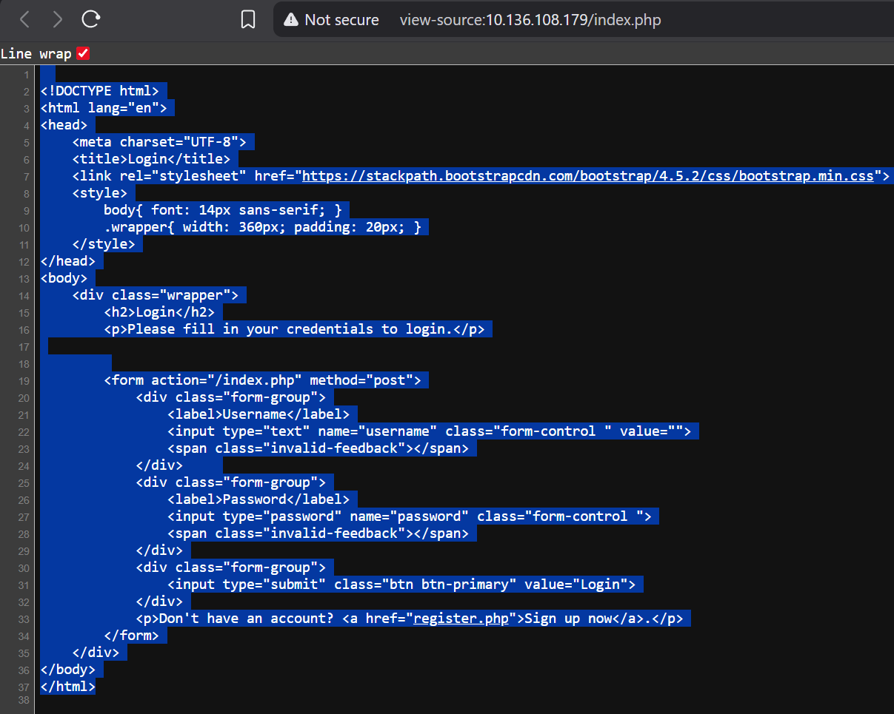  - Create new file as index.html and save the code  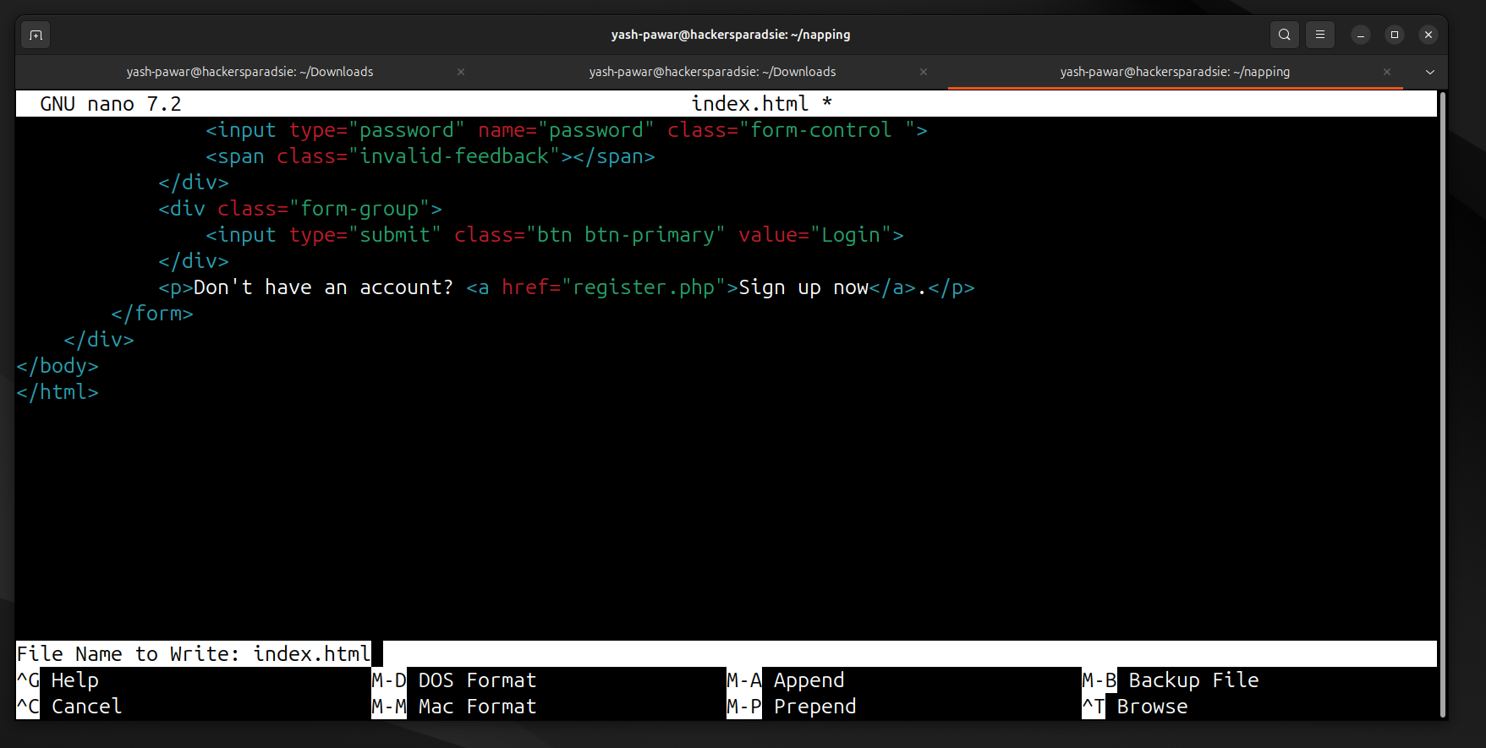  - We have two files now  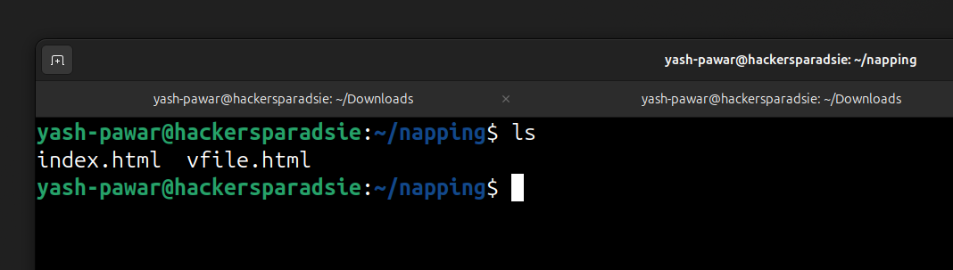  - Start python server here port 8080  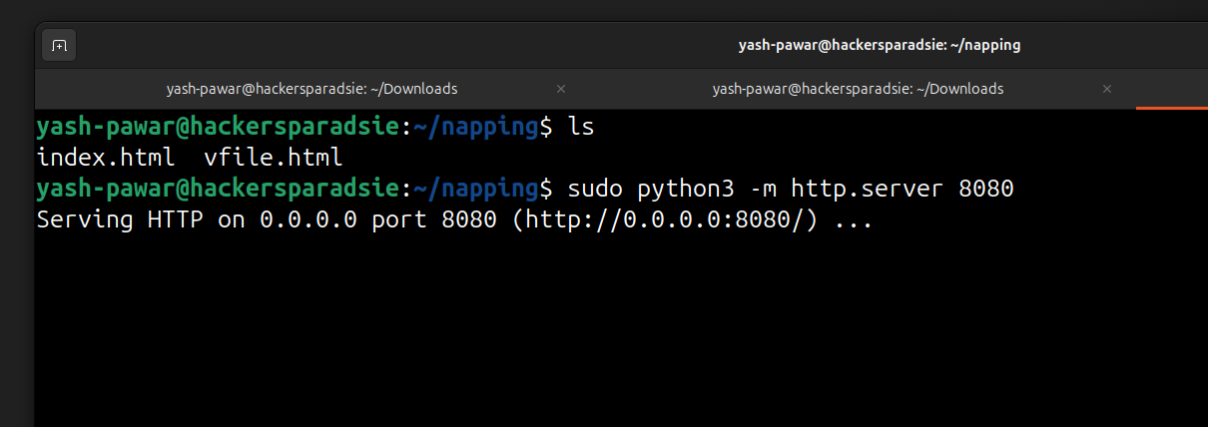  - Start netcat listener on 8000  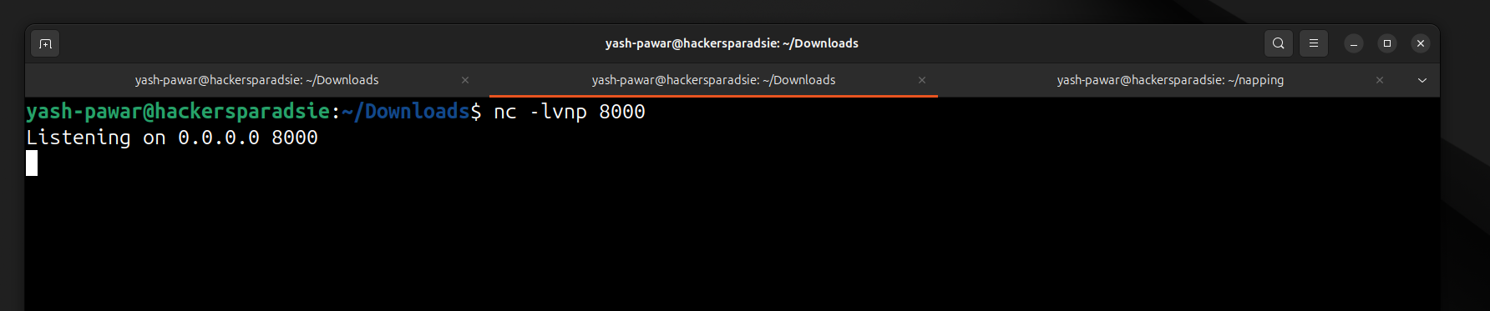  STEP 7 – Gaining Access  - Login to webpage again  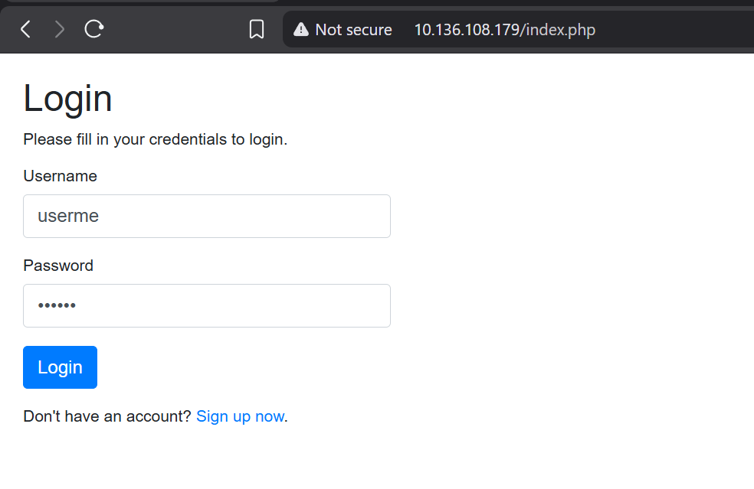  - Insert link of server to access the vfile.html  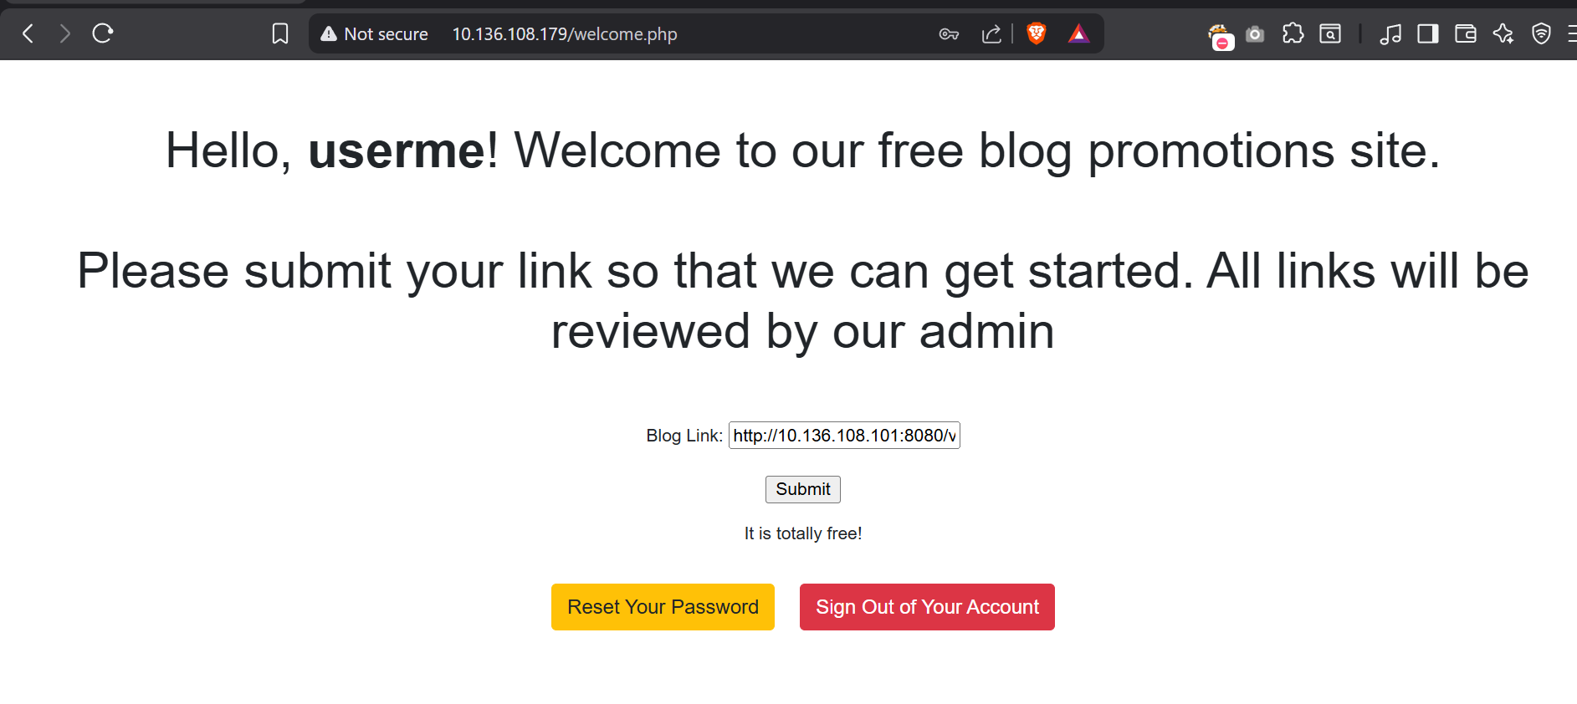  - Then click here after submit we will go on blank page and inspect  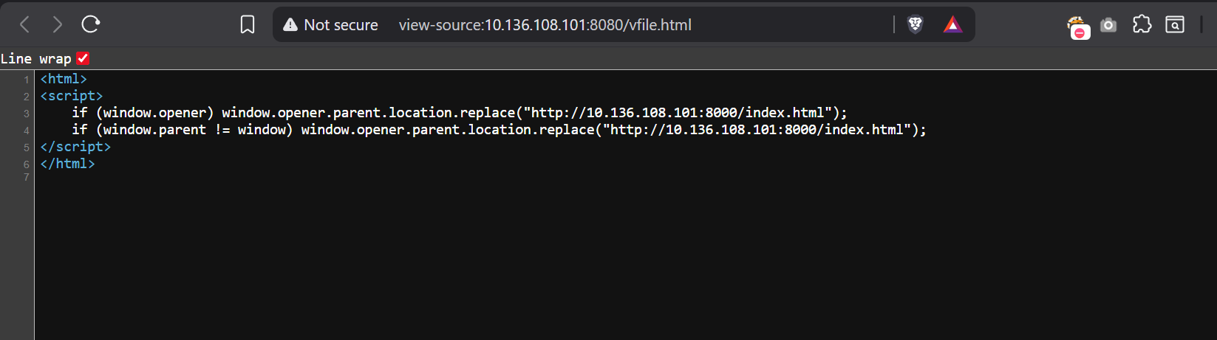  - We paste then link two three times on blog link option and the reload the page of vfile.html  - We will receive creds on netcat  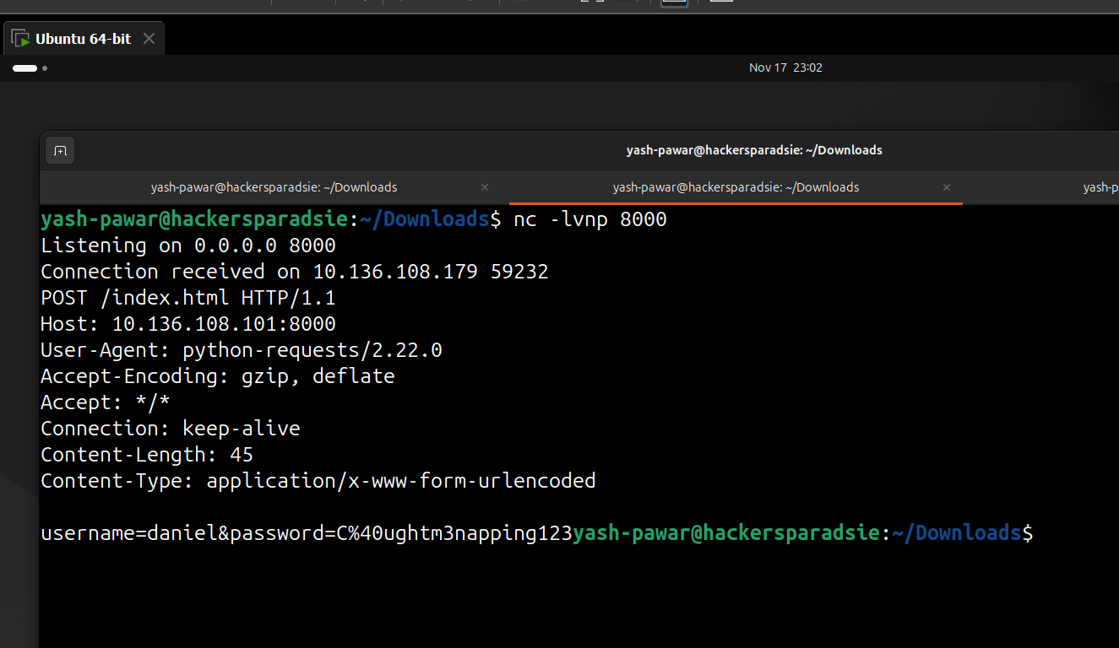  - Let’s URL DECODE it  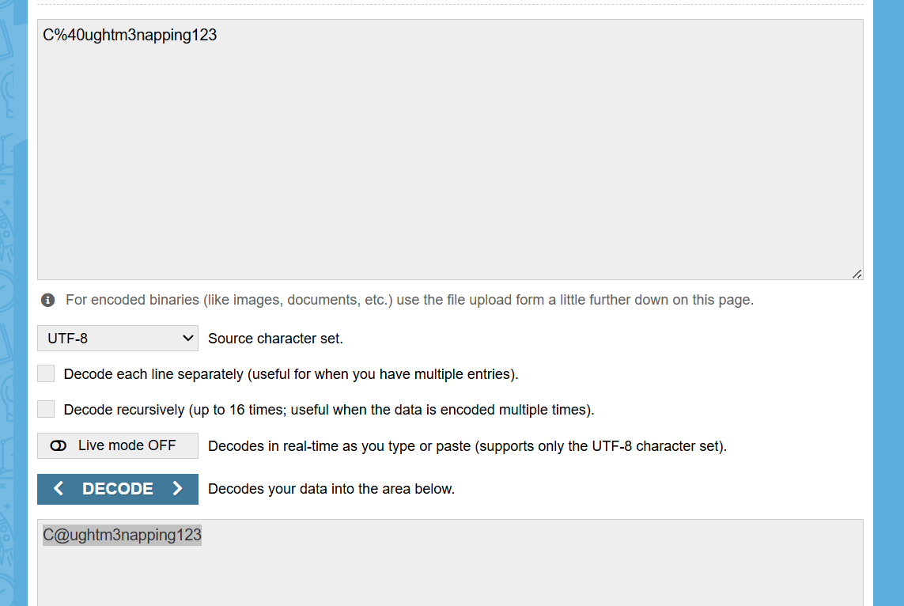  - We got creds  - Username: Daniel  - Password: C@ughtm3napping123  STEP 8 – Authenticate using ssh  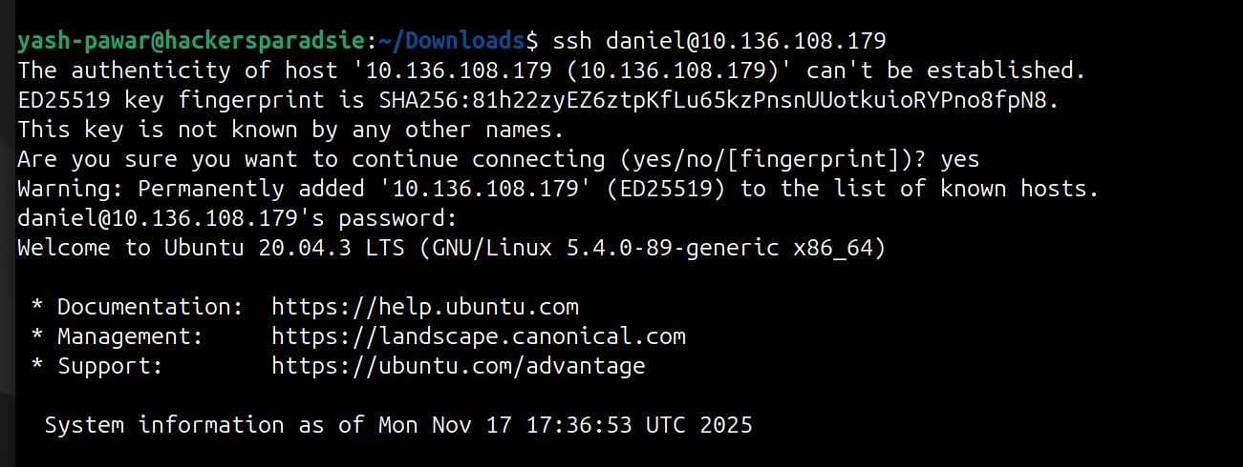  - Got login  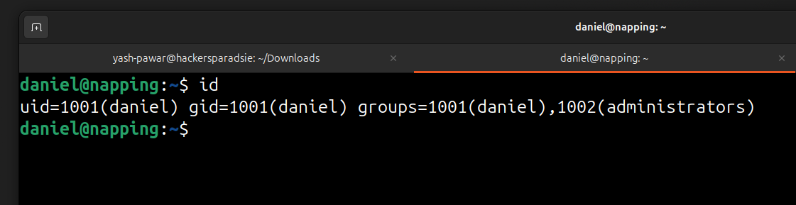  STEP 9 – Let’s try elevate privileges to root user  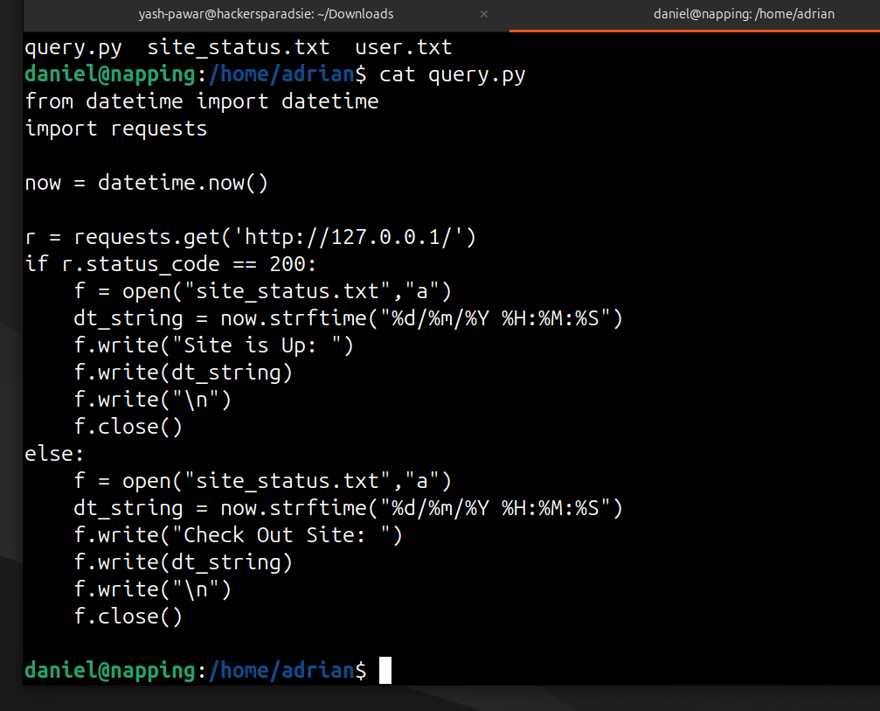  - Modify the data for reverse shell on netcat which is started on 9001  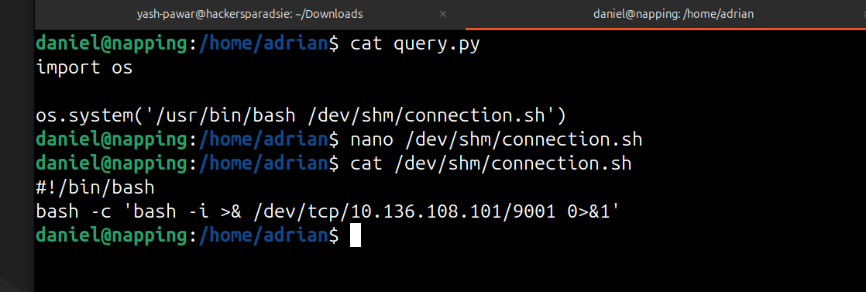  - Wait for cron to trigger it will run it automatically  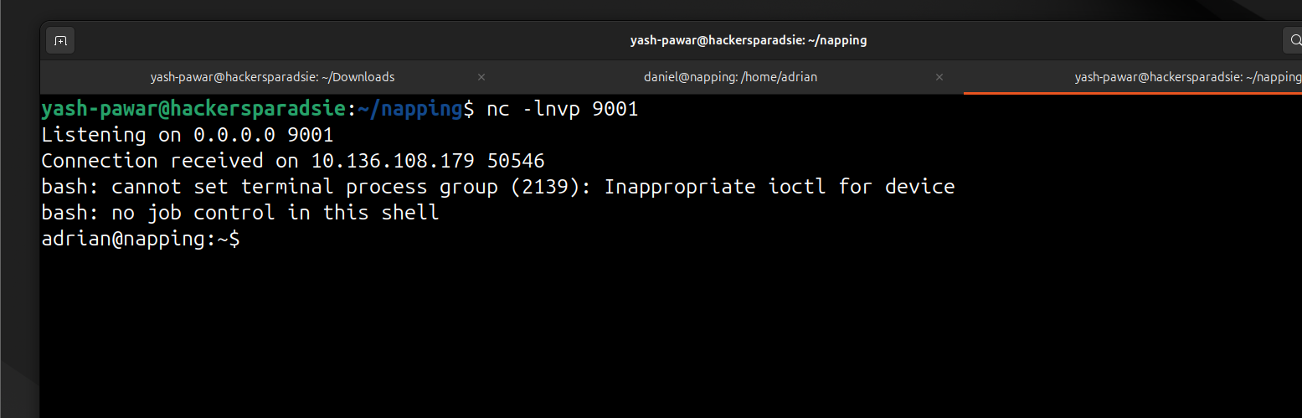  - Here we got shell on the target  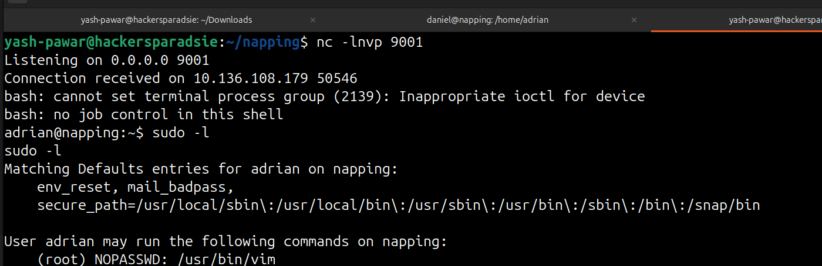  - Target can run this without password lets use GTFOBins  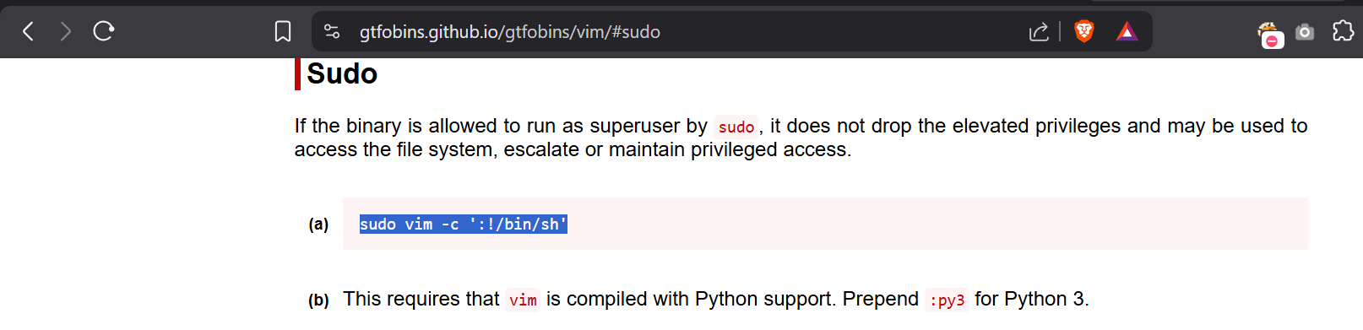  - We got root on target  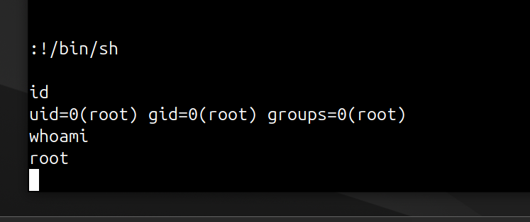  - Here is root flag  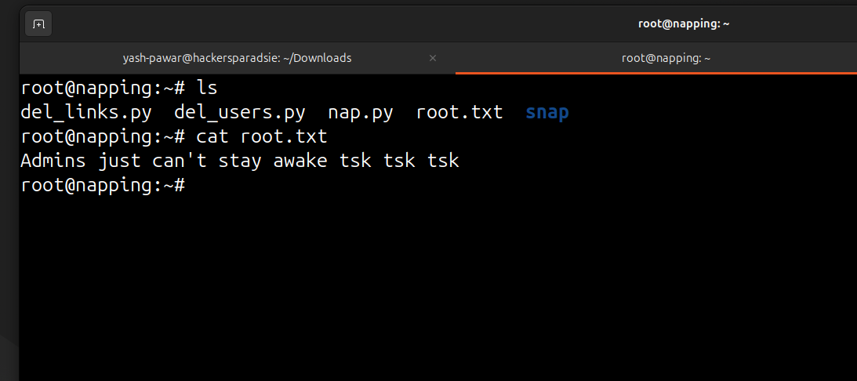
Impact | • Remote attacker can execute system commands from the web interface.  • Attacker gains a shell as www-data with access to application files.  • Misconfigured SUID binary allows a privilege escalation path to root.  • Full compromise of server, application, and stored data.
Remediation | • Fix input validation, remove system command execution from web functions.  • Replace unsafe shell calls with parameterized functions or APIs.  • Remove unnecessary SUID binaries and enforce least-privilege groups.  • Apply OS patching and restrict internal script access to trusted users only.
Reference | https://cve.mitre.org/cgi-bin/cvename.cgi?name=CVE-2014-6271  https://nvd.nist.gov/vuln/detail/CVE-2014-6271

